- Newsletter  November 2018  Lynton Trailers  Lynton Trailers have been selected to carry out the interior and exterior work to the Peugeot Boxer Van, based in Glossop they have a history spanning over fifty years, Lynton have been at the forefront of technology in the design and manufacture of trailers, demountable and motorised vehicles. Lynton Trailers has extensive expertise across many areas such as healthcare, emergency services and military applications along with exhibition, hospitality, display and training. | ‘VETERANS OUTREACH CONNECTION’ PROJECT.  This is a collaboration project within South Yorkshire. Its aim is to provide a voice for the veterans across the region through increasing awareness of services available to them, via the Military Community Veterans Centre’s Outreach Trailer.  The project includes the support of all four South Yorkshire Authorities, the MOD and Rotherham MCVC, however additional organisations will be encouraged to participate and drive the project forward also.  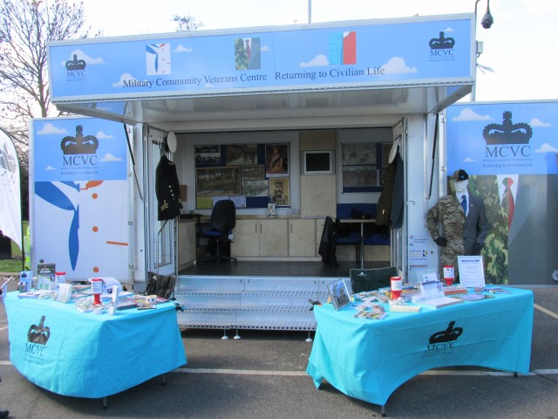  The MCVC Trailer  Funding has been provided to allow the purchase of a vehicle to tow the MCVC trailer to events throughout South Yorkshire in support of the four Local Authorities, Charities and Military Associations.  A post of Project Manager has also been funded for a two year period to develop and co-ordinate the project ensuring it is delivered fit for purpose, utilised as much as possible and effective in its use. Jim Oakes is the person in post and he intends to introduce himself to authorities, charities and associations as soon as possible.  Background.  Over recent years our engagement with the Armed Forces Community has been seen as “marking time” therefore, since taking over 2 years ago, along with all the South Yorkshire Authorities our ambition is to put into place measures to advance our services to that part of our community.  Cllr Ian Jones – Armed Forces Champion  Rotherham.  An initial assessment quickly revealed three major problems,  - Firstly we had no idea of where or who the community was.  - The depth of need and type of support required.  - The understanding by our frontline staff of the “Military Human” and their expectations.  To support this work we have drawn down from the Armed Forces Covenant Fund, just under £300,000.00. This has helped us to develop and promote a questionnaire to assess need through Sheffield Hallam University, train nearly 900 frontline staff how to identify and understand Veterans needs and to finally sign post them to any relevant services.  The last part of the funding is to develop an Outreach Service, one strand of the community survey clearly showed a need to further raise the profile of the covenant work within South Yorkshire on a ‘face to face’ basis.  The ‘Veterans Outreach Connection’ project aims to raise that profile by delivering engagement at events across South Yorkshire using a vehicle specifically designed to attract the Military Community in the same way many of the current regimental recruiting trailers do at these events.
- Contact details Project Manager  Name  Jim Oakes  Organisation  Rotherham MCVC  Phone  07496 455277  Email  Jim.oakes@rotherhammcvc.org.uk  Website  - www.rotherhammcvc.org.uk | FAQ’s  Q. “What type of vehicle has been purchased?”  A. The vehicle will be a first registered, LWB White Peugeot Boxer Van, it will have a towbar for towing the MCVC trailer. Two large bonded vehicle windows will be fitted to either side. The complete exterior of the van will be applied with digitally printed vinyl produced from designed artwork.  Q. “When will the vehicle and trailer be available for use?”  A. The vehicle has been ordered and Lynton Trailers are awaiting its arrival at their premises. Once they have possession it will take approximately 6-8 weeks for completion of the interior and exterior work. A realistic timescale for the vehicle and trailer to be completed and available for use would be March 2019.  Q. “What will the interior of the vehicle look like?”  A. The interior will be fitted out to provide a secure and private environment where meetings with veterans and their families can be held in warmth and comfort. This will include lockable storage cabinets with desktops, comfortable bench seating, workstations, a TV and 240 Volt electrical system.  Peugeot Boxer Van  