MCVC Newsletter September 2016
This newsletter is produced with the intent to reflect upon the events of the last few months, to update all our members and interested parties of where we currently stand, and to inform you of our aspirations for the future. A lot of the work is currently in hand and we hope to keep you all updated as we progress.
I am sure that most of you are aware that we have become extremely adept at: “Doing a lot with very little” and "Trying to connect the dots" ( Colonel Mac's favourite quotes at the meetings I have attended with him)
Bids are currently being constructed and/or in the pipeline that will hopefully allow us to progress with doing a great deal more with our assets. We have been able to swell the coffers courtesy of the “Outreach Team” doing their bit to get the public, to dig deep at events they have attended. The use of Dennis as a Homeless and Hungry veteran was certainly humorous and imaginative.
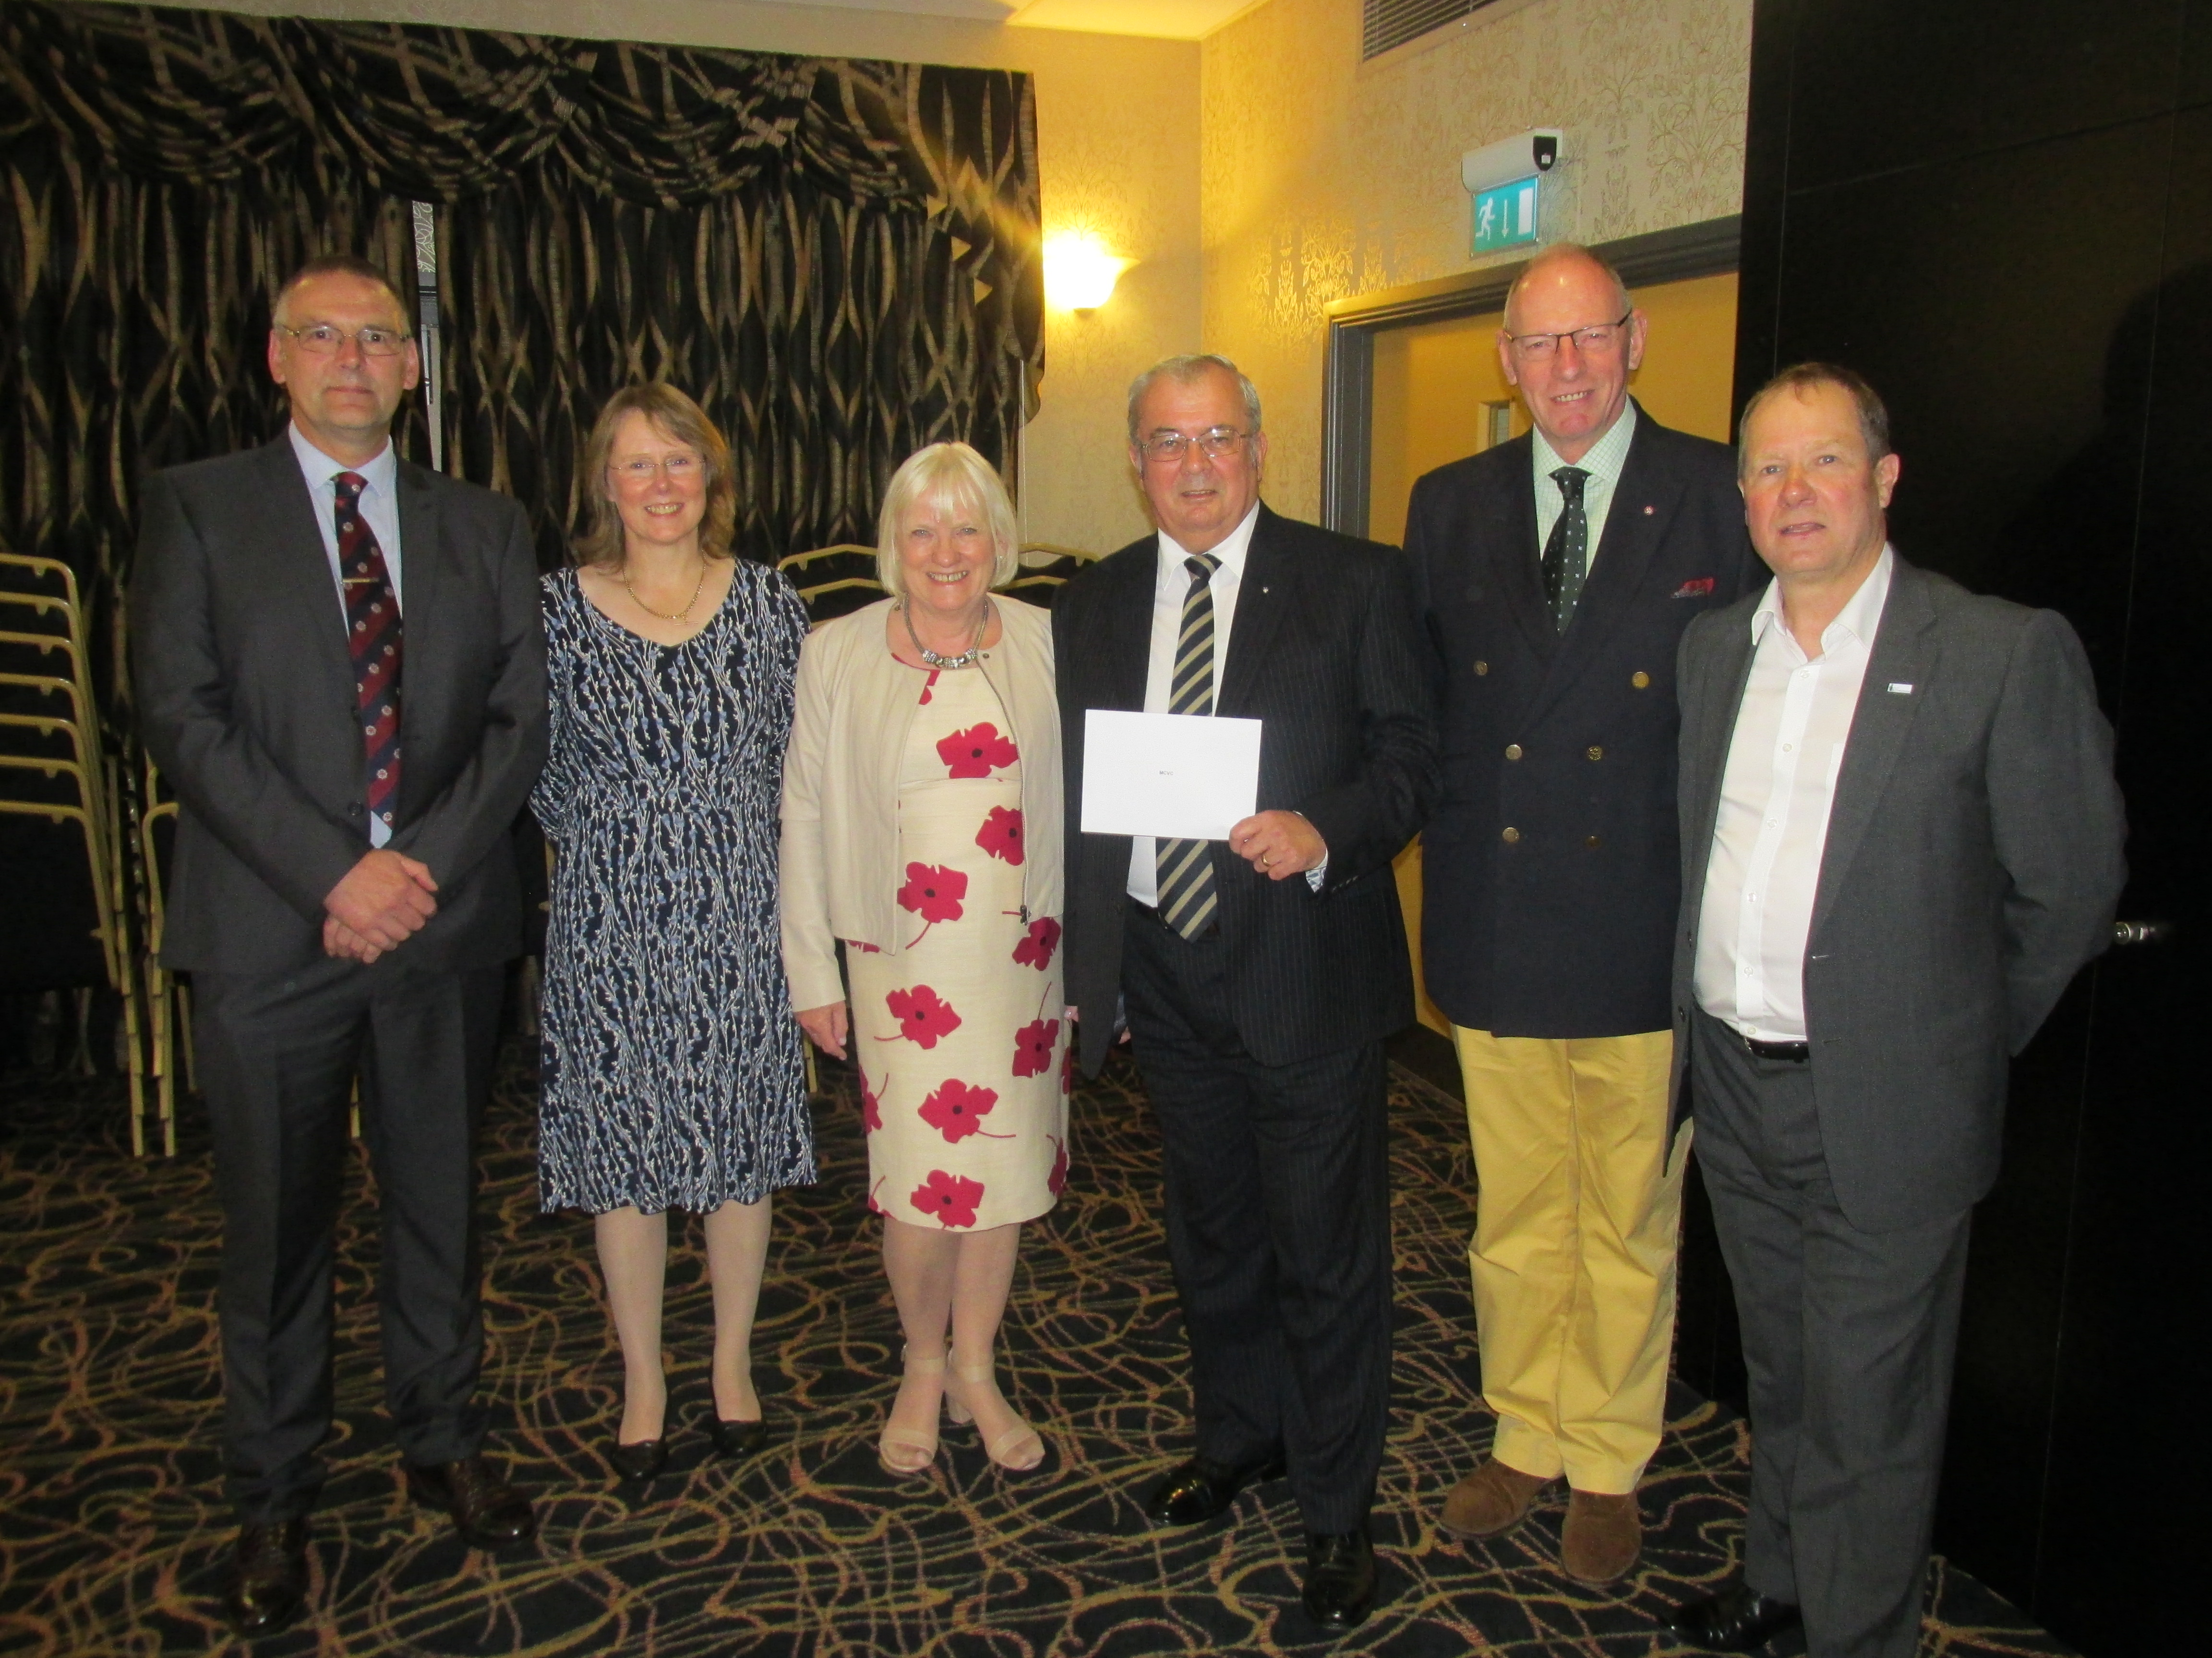
Donations have been gratefully accepted from a number of kind contributors, who have carried out sponsored walks, runs, and even a skydive to raise both awareness and funds. We are extremely grateful.Of particular note more recently, was the gift of £1000 from the outgoing Mayors charity. This was totally unexpected, but very gratefully received. The group has now attracted financial support from the Police and Crime Commissioner, Lord Lieutenant, High Sheriff, MOD, Heritage Lottery, Coalfields Regeneration, and RMBC, to name but a few.
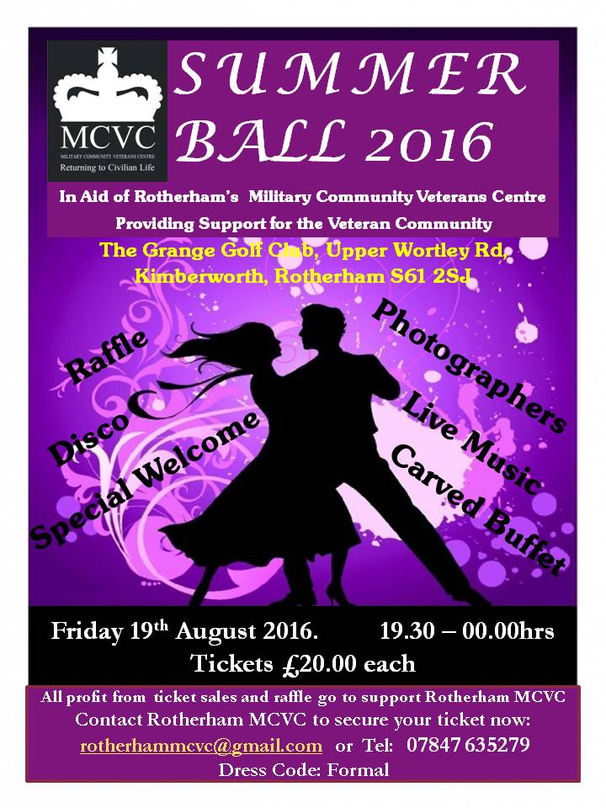
After the success of the Summer Ball, it seems an appropriate time to say a “Big Thank you” to Mac2 for his hard work and commitment, (in addition to all his other tasks) for organising and staging a fantastic event, which was well supported, by members, partners, local dignitaries, businesses, and supporters. We had several gifts donated to the raffle, (another success) which we are again extremely grateful.
The event was summed up as follows; After months of planning, sourcing, negotiating and selling of both entrance tickets and raffle tickets, the day of reckoning was finally upon us and at 7pm on Friday 19th August 2016 it was all systems go (with many fingers crossed and much hope for a good night) for the first Rotherham MCVC Fundraising Summer Ball.
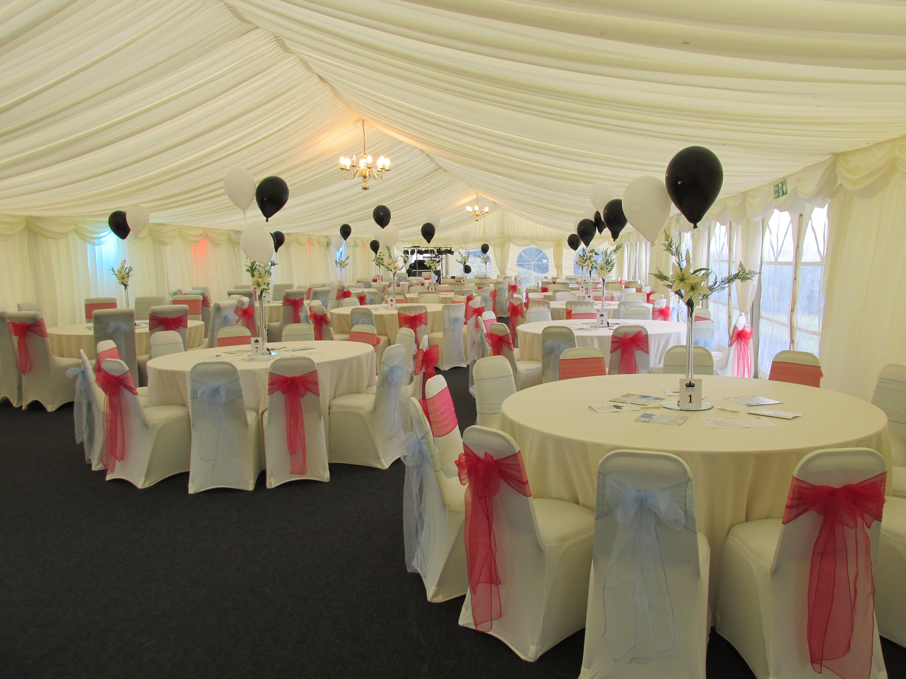
As guests arrived, including the Lady Mayor of Rotherham and her Consort (Cllr Lyndsay Pitchley and Mr Alex Armitage) they were welcomed at the entrance by our two pipers (Kevin and Jim from the Sheffield City Pipe Band). Then through the flashing cam netted tunnel to the reception drinks (Bucks Fizz or Orange Juice) and the bar where our team of photographers were on hand to capture that special moment with portrait photographs for those that wanted a momento of the evening.
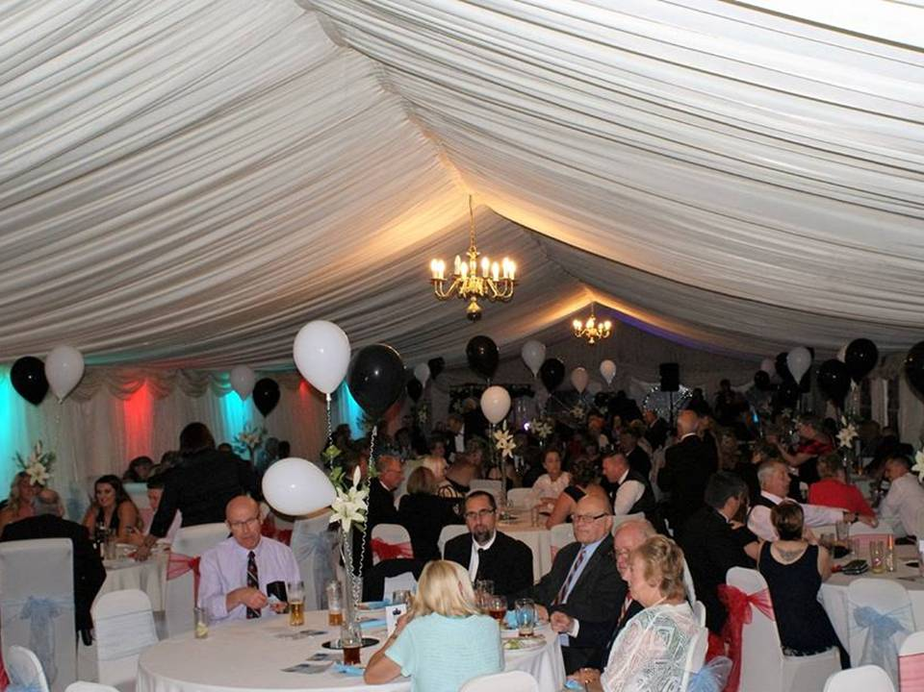
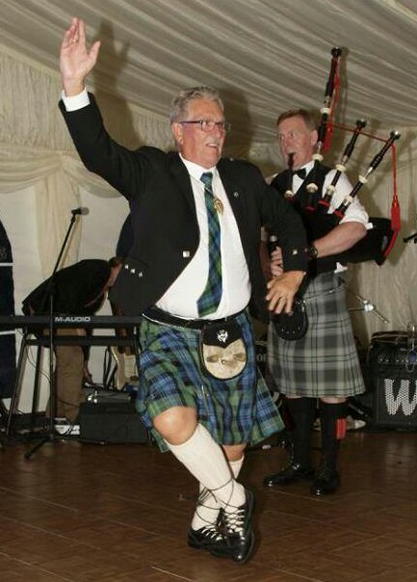
Grab a drink from the bar then into the marquee with chairs dressed in red and blue, tables decked with centre pieces, black and white helium filled balloons and a night of music and dancing, courtesy of the ‘Grange Disco’ and ‘Amplitude’ (Rock and Pop Function Band from Liverpool). Midway through the evening came the buffet, dressed salmon and cold carved meats produced for us by the Grange Golf Club Catering Team which was enjoyed by all.To save interrupting proceedings the raffle was drawn by the Lady Mayor of Rotherham and Mrs Christine McPherson while everyone else danced on.Then came the moment that Kevin and Jim got to blow us away (no pun intended) with their bagpipe playing (awesome), joined on the floor by the kilted Mayor’s Consort (Mr Alex Armitage) giving us a demonstration of his Highland Dancing skills. Then back to the Amplitude and the Grange Disco to dance the remainder of the night away. Then all too soon a fantastic night of partying was over and it was time to go home. Thank you to everyone that made the first Rotherham MCVC Fundraising Summer Ball a huge success (everyone who purchased a ticket, our sponsors, the Grange Golf Club, Amplitude, The Grange Disco, Mark & Chris our photographers, Sue Conlin for her raffle ticket selling skills and anyone else that we may have forgotten), we couldn’t have done it without you.
The Drop In goes from strength with now over 40 regulars attending. So great has been the success that new premises to accommodate the growing numbers, at Silverwood Working Men’s Club has been arranged to commence from October 7th 2016. This facility has been kindly offered to us for free, and will allow us to divert monies to provide even more valued support. Tea and coffee will be provided to allow business to continue as normal on a Friday morning between 1000hrs and 1200hrs. There is a large car park, regular bus service, and good local amenities.
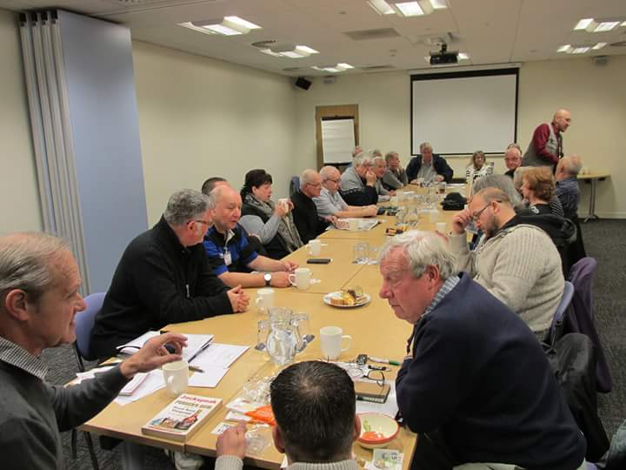
A new scheme has been launched to recognise the sterling efforts of the individuals who form our team.
Dennis Hardy was recently presented with a certificate by Sarah Champion MP on one of her visits to the Drop In.
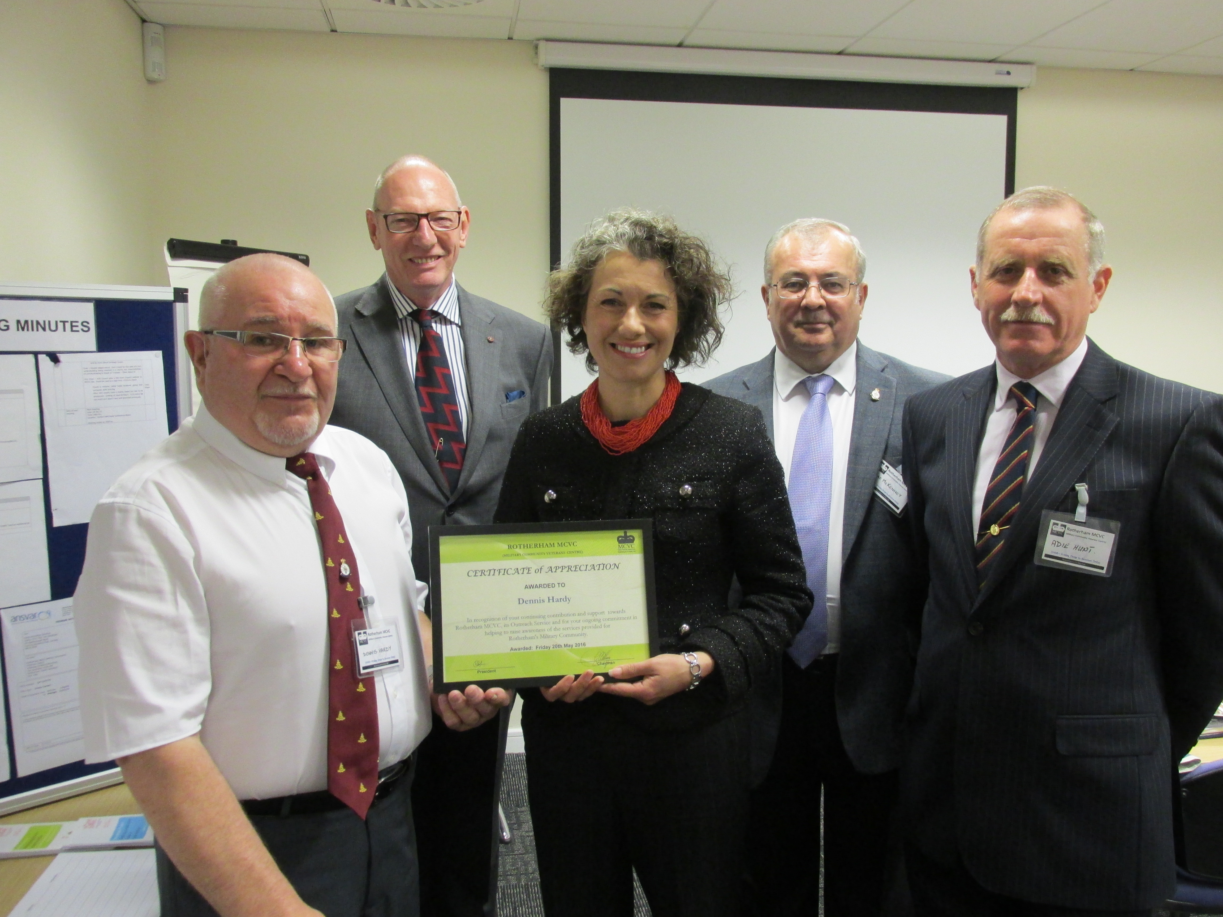
Bill Carroll has been another worthy recipient of a certificate for his hard work and support.
Special mention should also go to Paul Hoyland for his sponsored walks and Sarah Lee for her epic sponsored sky dive. Thank You both for your continuing support.
___________________________________________________________________________________________
The Breakfast Club continues to grow and flourish, meeting on a Saturday at the Bluecoats "Public House between 1000hrs and 1200hrs. Mac2 again deserves credit for setting this up and continuing to promote it.
___________________________________________________________________________________________
We now have several veterans who have engaged with the “Befriending Scheme”.
Several of the group have adopted these comrades in arms and conduct welfare calls and visits with them. Some of our new friends have been able to attend the "Drop In" due to volunteers arranging transport, in gestures of goodwill.
Assistance has also been provided by linking in with local agencies to provide support where needed.
If anyone is interested in assisting in the scheme please speak with Mac2.
The Outreach” trailer has been refurbished, and new graphics applied courtesy of some great designs being created by the students of RCAT. Work is in progress to create a looped video that can be played when the trailer is deployed which explains more clearly the work we do. This video will be produced utilising the video equipment we bequeathed to the college last year as part of the Heritage Lottery Fund grant.
The trailer is equipped with a defibrillator, which makes the group a valuable asset to the "community every time we are deployed.
Work is ongoing in trying to source a Multi-Functional Vehicle to help pull the trailer, to facilitate trips, and transportation. We hope that it will also offer the option to serve as a stand-alone outreach office that can be crewed by one or two members of staff.
Approaches have been made towards Mercedes-Benz to acquire a long base Sprinter Van to meet our requirements. Keep your fingers crossed that we can achieve a good deal and new partnership.
___________________________________________________________________________________________
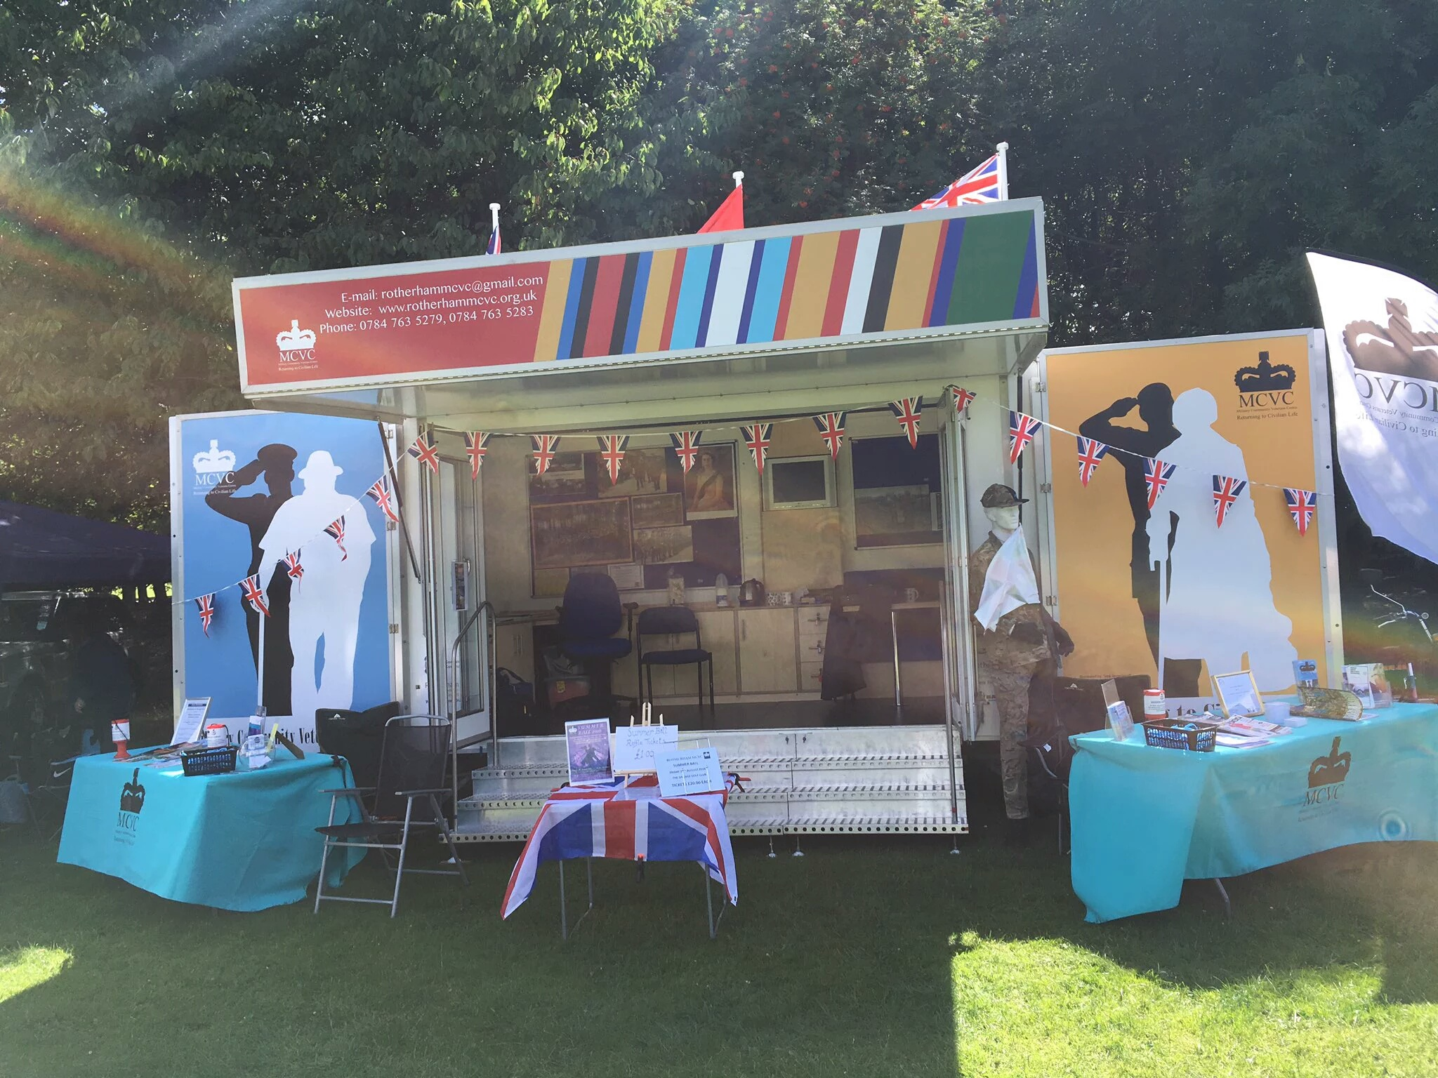
The group is heavily engaged with RMBC in promoting the Armed Forces Community Covenant. We meet regularly with the council and representatives of local services and businesses. We also continue to work with other charities which are both Nationally recognised or locally based. New links have been formed with "Project Nova", and "Care After Combat", to name just two.
The database of veterans and dependants that we support is growing. Although we cannot go into specific details, it is a fair claim to state that we as a group have saved lives, and supported individuals and families at a time of crisis. Our goal remains to improve upon our work year on year.
Discussions are ongoing at the moment re Asset Transfer, which basically means that we are hoping to have our own premises which will allow the group to assist with emergency temporary accommodation, holistic support, IT support, and creating our own revenue by renting space out to other parties.
To manage these projects we will of course need to employ full time members of staff and again bids are being processed to try to secure funding.

Following the AGM the Board of Trustees has lost several members.
Sadly Mike Webster has withdrawn due to the loss of his wife Mary. We offer him our Thanks, and deepest condolence’s. We also offer our thoughts to both him and his family , wishing them the very best for the future.
Andy Holt has had to withdraw due to health reasons. Again we offer our Thanks and wish him good health and a happy retirement.
We have several new potential Trustees who have been approached , and Adrian Hunt, who kindly stepped in as Temporary chairman of the Board of Trustees, has work in progress to create the new team. We will of course update the group as soon as possible when all the posts have been filled.
____________________________________________________________________________________________The Executive Team continue to work behind the scenes.
We have had one loss since the AGM.
Diane Wilks has decided to stand down but still offers her support to the Group. Again I would like to say a big thank you to her for that support. Particularly for her actions at a time of crisis for a very vulnerable veteran who has gone on to make a good recovery.
____________________________________________________________________

The future of the group at the moment looks very bright, lots of work is in progress, lots of new people wish to get involved with us.

Onwards and Upwards !!!!!
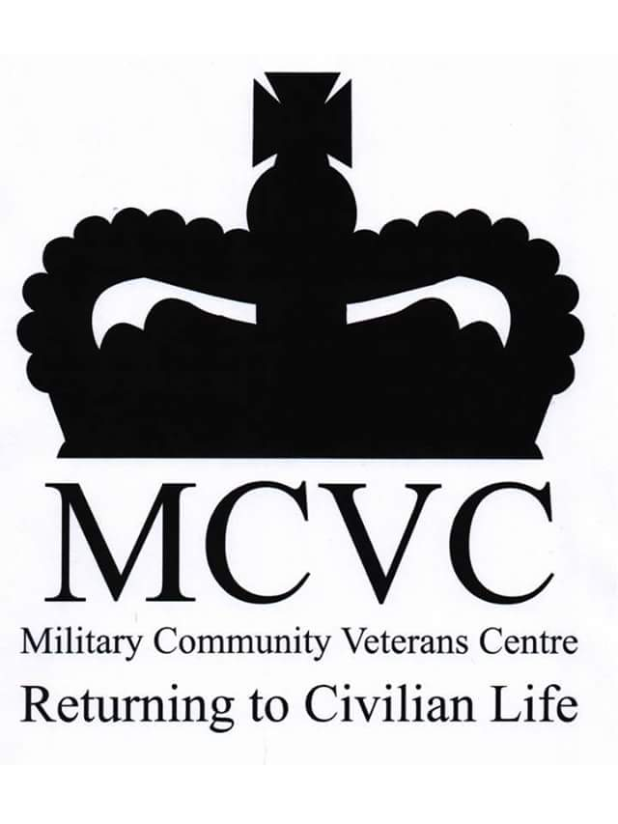
Dennis Morgan

Here are a few Highlights of what we do and achieve;
